ER Model

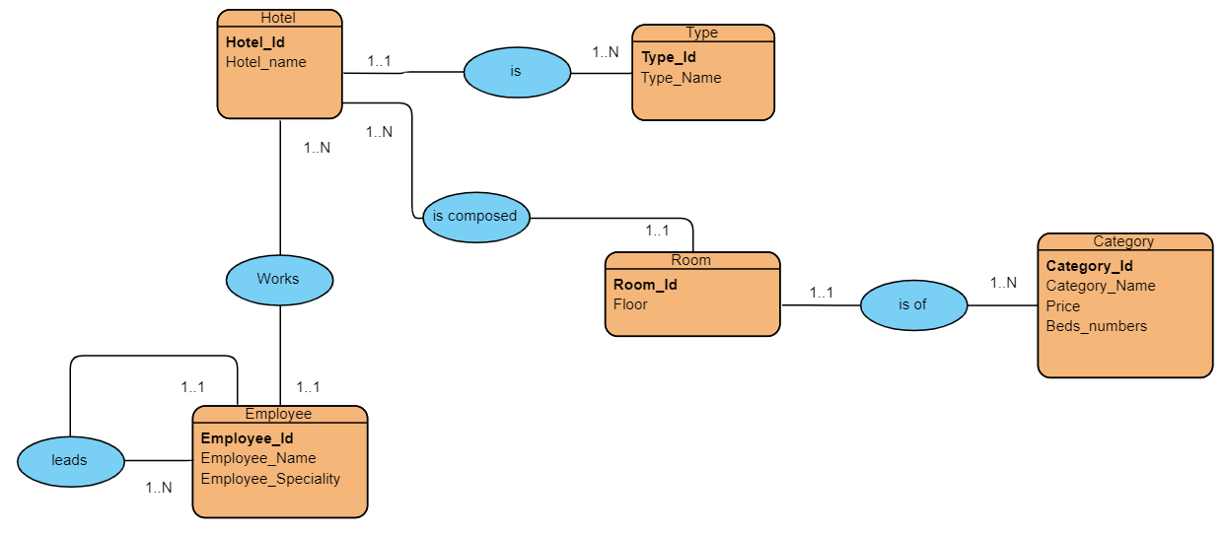

Diagram Model

Hotel (**Hotel_id**, Hotel_name, #Type_id)

Type (**Type_id**, Type_Name)

Room (**Room_id**, Floor, #Hotel_id, #Category_id)

Category (**Category_id**, Category_Name, Price, Beds_Numbers)

Employee (**Employee_id**, Employee_Name, Employee_Speciality, #Hotel_id, #leader_id)